2.4 Unit Tangent, Normal, and Binormal Vectors

Tangent Vectors
Recall that in section 2.2 we discussed the idea of creating tangent lines to smooth vector-valued functions. Specifically, we stated the following definition.

Definition: Suppose that . The vector is called the tangent vector to the curve C at t.
Therefore, we call, the unit tangent vector.

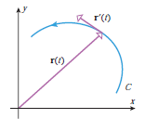
Example 1: Find the unit tangent vector to the graph of at the point where .

We calculate that .
Therefore, represents the tangent vector to .
So, is the unit tangent vector.

Normal Vectors

Recall that in section 2.2 we also introduced the following theorem.
Theorem: If is a differentiable vector-valued function in 2-space or 3-space and is constant for all t, then

that is, and are orthogonal vectors for all t.

Using this theorem we can conclude that since has a constant norm (that is, is constant) then is orthogonal to it. This leads us to the following definitions.

Definition: Provided that , we call a normal vector to the curve C at t.
Therefore, we call the principle unit normal vector to C at t.

Notice that there exist multiple normal vectors to a curve C and a given point t. Therefore, the idea of the principle unit normal vector is specifying a specific vector out of these several possibilities.
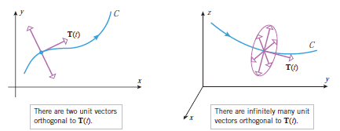

Note: As with the principle square root, if we are asked to find the unit normal vector, it is assumed to be the principle unit normal vector.

Example 2: Find the unit normal vector to at .

This is the same curve from Example 1. So we already know that , but we need to find so that we can also findand therefore .

We know that and thus .
Therefore, .
So, which gives

Thus,

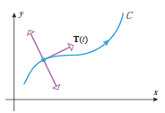
As we mentioned above there are actually many different normal vectors to a given curve. As shown above in 2-space there exists exactly 2 normal vectors to the curve C at the point t.

Theorem: Let C be a smooth curve in 2-space. The principle unit normal vector at each point along C is the unit normal vector that points inward (towards the concave side of the curve).

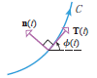
Proof (not done in class):
Let be the angle between the positive x-axis and , .
Let be the vector obtained by rotating counter-clockwise by radians.
Since is a unit vector we can express it as and since is just a rotation of we can express as:

Clearly represents a normal vector to the curve C since it was a radians rotation of a tangent vector, but we also know that is a normal vector to C. Interestingly we see that:
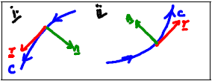
So, if (i.e., is increasing) then
and point in the same direction.

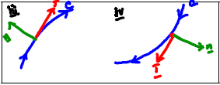
If (i.e., is decreasing) then
and point in opposite directions.

Therefore, since it always points towards the concave side of the curve.

Note: In 2-space is commonly referred to as the inward unit normal.
Binormal Vectors

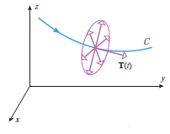
In 3-space there are infinitely many normal vectors at a point on C. is just one of these vectors, specifically the vector that when paired with determine a plane which is tangent to C. This plane is called the osculating plane.

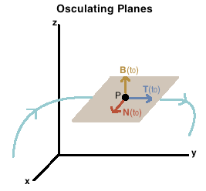

Definition: If C is a graph of a vector-valued function in 3-space, then we define the binormal vector to C at t to be

Note: is a unit vector.

Example 3: Prove that is a unit vector.
We see that and we know that where is the angle between u and v. Since and are perpendicular we know that and therefore we have:
Therefore, is a unit vector.

Definition: A coordinate system determined by T, N, and B is called the TNB-frame or the Frenet-frame.

Theorem: The binormal vector can be expressed directly in terms of as:

Proof: Follows from the definitions of , , and .

Example 4: Find the binormal vector to at .
We plan to use the above formula to calculate ,
First we compute the following:

Therefore,

OR

From example 1 and 2 we know that and .
Therefore

Note: Both approaches to calculating produce the same result.

